GRASSHILL CHAMP'S TRENDSETTER -[CAN]S101806- born December 6, 2006
Paternal Brother to ‘Diana’, one of the World’s Highest Saanen Producers (3688 kg in 305 days)

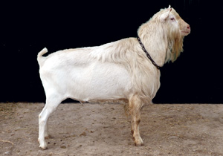  Grasshill Champ’s Trendsetter VG | Full Sisters to Champ:  Chelsea EX, 2372 kg 3.4f 3.1p  Others too young for EX:  ChinookII VG, 2050 kg (305 days)  Chantal VG, 2093 kg (305 days) Maternal Sisters to Champ:  Cherish EX 1915 kg, Wend VG 2662 kg  CHeiress 1yr4m: 2232 kg 3.7f 3.0p |  |  |  |  | ROCKY-RUN JP'S SORCERER -[CAN]S86937- VG, *S
 |  |  | 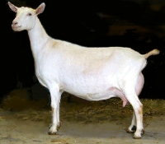  Honour’s Dam: Jaklyn | GRASSHILL JAKLYN'S HONOUR -[CAN]S90114- VG- 88  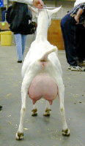  EX, GCH |  | His dam:  Rocky Run S Scamp EX (USA), 8*M  3yr0m 305d 1482 kg 3.9f
HY-CREST JUNO'S JAKLYN -S67757-
Jaklyn, EX, *P, 1524 kg 4.0f 3.35p
← Former ‘All Canadian’ Saanen East National Grand Champion,
Royal Winter Fair GCH & Best Udder

,--
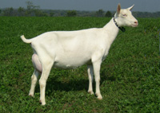  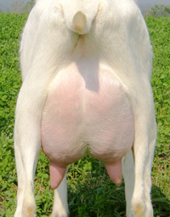 | 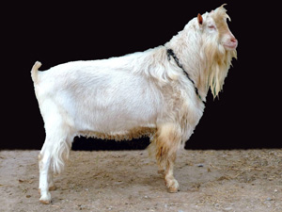  First 28 daughters 2nd lact avg:  1766 kg 3893 lb (305 days)  First 26 daughters: 81% VG or EX | GRASSHILL HONOUR'S CHAMP -[CAN]S98616- EX
 |  |  |  |  |  | SINGING-SPRUCE VORTX POLLONADE -S68500- EX
 |  | 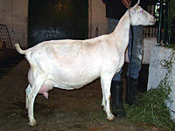  Chablis EX, 2074 kg 3.8f 2.9p (305d)  4 daughters over 2000 kg (305 days)  3 are full sisters of Champ |  | KAMPFIRE C POLLONADE'S CHABLIS -[CAN]S76726- EX (below) |  | Sired 3 daughters at Grasshill, all 3 EX
Full Sister to Trendsetter: (above)  Tipperary EX, 2151 kg 4.1f 3.4p |  |  |  |  |  | HY-CREST LIASON CARRIE -[CAN]S69856- VG, *P
GRASSHILL CHAMP'S TRENDSETTER- VG-89 | 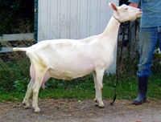  High Component Dam: Tara
High Production & Type…  both sides of the Pedigree!  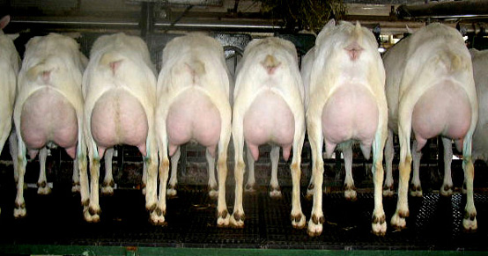  Members of Trendsetter’s Family  2nd, 3rd & 4th does are  Full or 100% Sisters to Tara  i.e. 2nd: Gypsy VG-89, EX mammary  1803 kg 3.6f 3.5p  3rd: Sweet Pea EX: 1847 kg 4.3f 3.3p  4th: Shnooks EX: 2158 kg 3.5f 2.9p |  |  |  |  |  | KAMPFIRE J VADE'S JACKSON -[CAN]S77825- VG
 |  | 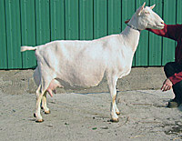  Grasshill Shamorck’s Lady |  | GRASSHILL SHAMROCKS LEPRECHAUN -[CAN]S82683-
 |  |  |  | 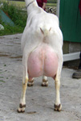  EX, 2471 kg |  | GINGERBREAD LADY SHAMROCK -S56828- EX, 1840 kg , 3.4f 3.3p  3 EX daughters, sons sold as herdsires  ←Daughter Lady 2471 kg 3.7f 3.2p
 |  | GRASSHILL LEPRECHAUN'S TARA -[CAN]S85764- (above)
 | Tara: VG-89, EX mammary  6yr0m 305d: 2430 kg 4.7f 3.8p  High Production& High Protein  2 EX daughters over 2000 kg  & 2 daughters with avg 4.8f 3.7p nearing the end of their 1st lactation |  |  |  |  | SINGING-SPRUCE VORTX POLLONADE -S68500- EX
 |  |  |  | KAMPFIRE J POLLONADE'S JAMOCHA -[CAN]S76168- EX, 4.7f 3.8p
 |  |  |  | Daughters: 2 EX, 2 VG-89, 4 EX mammary |  | HY-CREST JANA -[CAN]S69943- EX

